Time Catcher by Cheree Peters

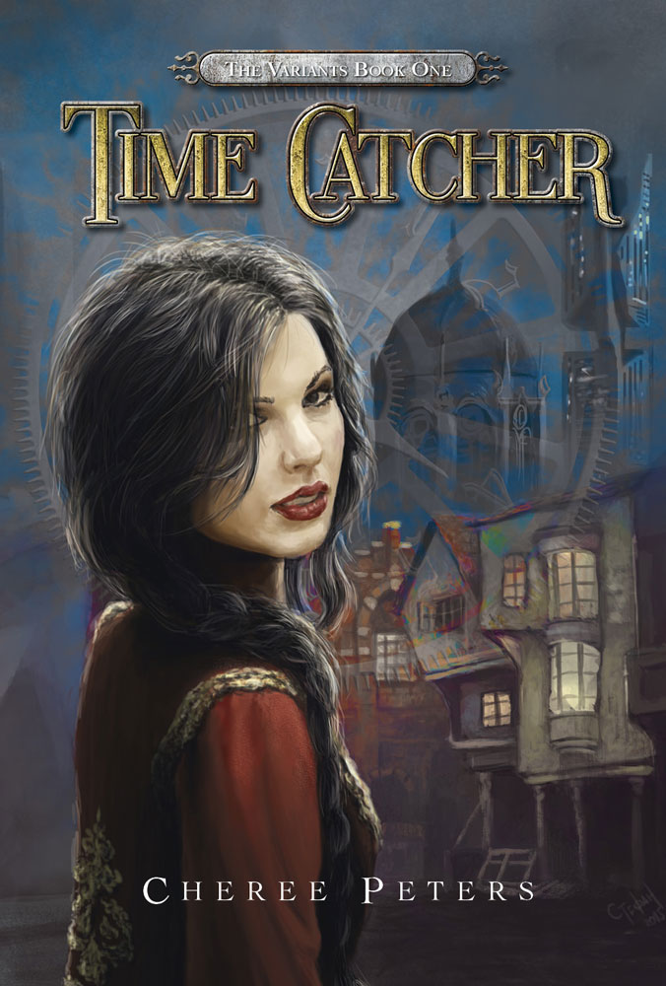

Synopsis

The first book in The Variants trilogy, Time Catcher is a science fiction book for students aged 12+.

In a post-apocalyptic world of rigid rules, Althea’s luxurious life is turned upside-down when she is kidnapped by the dreaded Variants. Betrayed by those she trusts most, Althea is forced to question everything she thought she knew – including who she is and what she’s capable of. Are the Variants dangerous insurgents or a new breed of human, fighting for freedom?

Althea must separate deception from truth to claim her own power.

About the author

A love of reading delivered Cheree into a degree in Creative and Professional Writing. With a particular passion for young adult books, Cheree decided to write her first novel in that genre. When she isn’t writing, Cheree works as a production assistant.

Time Catcher is Cheree’s first novel.

Presenting Time Catcher

What’s in a name?
- Have a class discussion about the cover of Time Catcher.
What things stand out about it? How does it link to the title of the book? Why do you think this title was chosen? What expectations do you have for the book based on its cover?

Genre
The Australian Curriculum: English describes genre as ‘The categories into which texts are grouped. The term has a complex history within literary theory and is often used to distinguish texts on the basis of their subject matter (for example, detective fiction, romance, science fiction, fantasy fiction), form and structure (for example, poetry, novels, biography, short stories)’.

A knowledge of a range of different genres and their conventions allows for an understanding of how and why each genre appeals to its readers. It also provides a foundation for students to create and experiment with their own writing.

- What are the some of the different genres? What are the conventions associated with these genres? Which genre does Time Catcher fit into? How do you know?

Focus: What is fantasy fiction?
Fantasy fiction is a genre of writing in which the plot could not happen in the universe as we know it. Often, the plot involves magic or witchcraft and takes place on another planet or in an undiscovered dimension of this world. The overall theme of the setting is frequently resembles medieval times, meaning that some combination of the architecture, clothing, language, and technology resembles the European Middle Ages. The plot also usually involves mythical creatures, and witches or sorcerers. Writers of fantasy fiction often devote a series of books to the same world or characters.

In her book, A literary companion for teachers, Lorraine McDonald describes the following conventions of fantasy:

- often includes a portal or an entry point characters have to cross between the primary and the alternative worlds
- often constructs a journey or a quest
- may use underground caves and/or passages
- alters time - called 'time-slip' or time travel fantasy
- often merges the past with the present
- often has parallel primary and alternative worlds
- often draws on myths and features of medieval traditions
- can be set in the future, in a virtual reality, in the paranormal (ghosts present)
- presents countries with their own history, geography, maps, legends and prophecies
- portrays characters who can have powers and/or special qualities, can see the future, read minds
- includes magical animals and beasts
- gives animals human qualities, especially speech - called 'anthropomorphism'
- introduces characters' names, habitats, clothing which are often unusual and different to modern times
- can include formal language in the narration and the characters' speech
- presents objects or clothing which have special powers
- constructs codes and chants which often hold secrets
- has a frequent major theme that evil exists in the world and needs to be overcome.

McDonald, L. (2013). A literature companion for teachers. Newtown: Primary English Teaching Association Australia.

In the beginning

- Examine the various pages at the beginning of the book: imprint, title page, contents page. What information do we get from these pages? What is an ISBN? What does the copyright information mean? Who is the publisher? Why is this information important?
- Discuss first impressions and expectations. Does the opening grab you? What literary devices are used to achieve this?
- What do we learn about the world that the novel takes place in from the first chapter? Who is introduced? How are they introduced?

Language and structure

To aid in the creation of visual imagery the author has used a variety of language techniques.
- Find examples of similes and metaphors in Time Catcher. Re-write them to create the same effect using different imagery.
- Choose a passage from Time Catcher and identify different literary and grammatical devices used e.g. nouns, adjectives, verbs, hyperbole, personification, onomatopoeia. What is the effect created by each device?

Althea's father tells her not to use contractions.
- What are contractions? Why might he tell her not to use them?
- Find some instances of contractions in the book/find some instances where contractions could have been used. How does using or not using them change the tone?

There are several instances of non-English, colloquial language, and even some made-up words in Time Catcher. Find them and make a glossary.

Colour features significantly in Time Catcher, particularly blue, black, and red.
- What literary or grammatical techniques have they used to ‘paint’ the colours?
- What effects does this create? Why do you think the author has done this?

Focus: Language for interaction
Age, status, expertise, and familiarity influence the ways in which we interact with people, and these interactions influence the way people engage with ideas and respond to others.
One way of showing this in a text is through dialogue.

- Find a passage of dialogue where Althea is speaking to an adult, and one where she is speaking to someone her own age. How can you identify who is speaking? How is the language different in each of these conversations? Why do you think that is? What different ways do you speak to people in your life?
- Has the author constructed interactions and exchanges between characters in any other ways?

Focus: Narration
There are three types of narrative technique:
- First person, where the point of view character (the voice telling the story) uses the word ‘I’.
- Second person, where the point of view character addresses the audience directly and uses the word ‘You’.
- Third person, where the author uses the words ‘he’, ‘she’, and ‘it’ to refer to the characters, including the point of view character. This type of narrator can be omniscient (all knowing like ‘the eye of God’) or can report events as they take place.

- Discuss the narration used in this book. Who is the narrator? What method of narration has been used? How can we identify this? Why do you think that the author chose this method?

Focus: Tense
Stories are usually written in past or present tense.
- What does this mean? How can the tense in a particular story be identified?
- What tense has the author used in Time Catcher? Why do you think she chose this?

Context/setting

The Australian Curriculum: English defines context as ‘The environment in which a text is responded to or created. Context can include the general social, historical, and cultural conditions in which a text is responded to and created (the context of culture) or the specific features of its immediate environment (context of situation). The term is also used to refer to the wording surrounding an unfamiliar word that a reader or listener uses to understand its meaning’.
- Discuss the social, historical, and cultural context created or presented in Time Catcher
- What is the difference between context and setting?
- Time Catcher takes place in a fictional world. What cultural differences are explored? How are these presented? What similarities or differences do you notice about the culture in Time Catcher and that in Australia?

Creativity/imagination

- The lives and characters in books exist only on the page but authors often hint about what might have happened to them before. Choose one of the minor characters you have met, take what you have learnt about them and use it as a basis to write about something that happened to them before the events of the story.
- Choose a character that you had strong feelings about (either positive or negative), and write a character profile, explaining why you think they are the way that they are and what makes you feel so strongly about them.
- Variants can have many different abilities; Althea can catch time, Eli can vault between spaces. What other abilities not mentioned in the book can you think of that Variants might have? Write up a profile.
- Design a quiz based on the abilities mentioned in Time Catcher for people to work out ‘What kind of Variant would you be?’

Comprehension

- Present the events of Time Catcher to the class in your own words.
- Write a review of it for an online book review site. Remember that an online review site can be accessed anywhere in the world, how can you make this story appeal to students outside of Australia?

Discussion

Use Time Catcher as a starting point for a discussion on:
- authority
- relationships
- family
- courage
- friendship
- class differences
- racism
- love
- punishment
- revenge
- imagination
- memory
- war
- genealogy
- medical testing.

Research

Use a theme, idea, issue, or character from a story as the basis for starting a research project. Some topics could be:
- The meaning of dreams
- A king or queen
- A republican system of government
- Female political leaders
- Parades and local customs of different cultures
- Civil War
- Eugenics.

Curriculum Links
The Australian Curriculum: English asserts in its Rationale that it 'helps students to engage imaginatively and critically with literature to expand the scope of their experience'. One of its Aims is to ensure that students 'develop interest and skills in inquiring into the aesthetic aspects of texts, and develop an informed appreciation of literature'. To facilitate this the Content Structure of English is built around the three interrelated strands being: Language — knowing about the English language; Literature — understanding, appreciating, responding to, analysing and creating literature; and Literacy — expanding the repertoire of English usage.
Time Catcher is useful in exploring all of these elements in the curriculum. It uses many features of language, and can be used to explore vocabulary, parts of speech, and sentence structure as outlined in the ‘Language’ strand. The above activities focus especially on the ‘Language for interaction’ and ‘Expressing and developing ideas’ sub-strands.
Time Catcher also encourages critical engagement with texts. It inspires discussion of literary experiences, sharing responses, and expressing a point of view. It raises questions about social status and interaction, loyalty and heroism, and variety of other topics and issues. In addition, it invites debate in a broader context about war, gender roles, and prejudice. These issues create links to the cross-curriculum area of Civics and Citizenship. It asks students to draw parallels between a fantasy world and their own world, placing emphasis on exploring values, rights, and responsibilities.
Time Catcher is aimed at readers aged 12+ so can be effectively used with year 6 and above.

